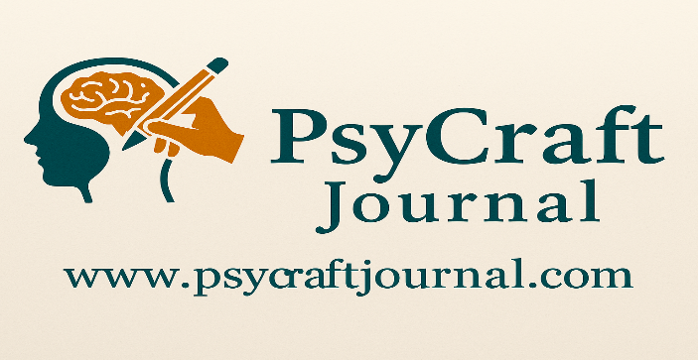 | PsyCraft Journal Copy Right Agreement  (Authors)

1. Manuscript Information
Title of the Manuscript: ____________________________________________
Corresponding Author: ____________________________________________
Manuscript ID (if assigned): ______________________________________

2. Copyright Transfer
I/we, the undersigned author(s) of the manuscript named above, hereby agree to transfer all copyrights of the manuscript, including all rights to reproduce, distribute, transmit, publish, or otherwise use the work in all forms and media, now known or later developed, to PsyCraft Journal once the manuscript is accepted for publication.
This transfer includes, but is not limited to:
- The right to reproduce and distribute the work;
- The right to include the work in electronic databases;
- The right to translate and adapt the work for indexing and archiving.

3. Author Warranties
The author(s) affirm that:
- The manuscript is original and has not been published elsewhere, nor is it under consideration by another journal.
- The manuscript does not violate any copyright, trademark, trade secret, or other personal or proprietary rights.
- All co-authors have seen and agreed to the submitted version.
- Permissions for any reused content have been properly obtained.

4. Rights Retained by Authors
Authors retain the following rights:
- The right to use the manuscript for personal and academic purposes.
- The right to deposit versions in institutional repositories with proper citation.
- The right to reuse content in future works with appropriate citation.

5. Final Clause
This agreement becomes effective upon the acceptance of the manuscript for publication in PsyCraft Journal.

6. Author(s) Signature(s)
Full Name | Affiliation | Signature | Date
If the manuscript has more than three authors, additional signature lines may be appended.
Please upload the signed version of this agreement as a separate file along with your manuscript submission.

